Electric Longboard Mark II

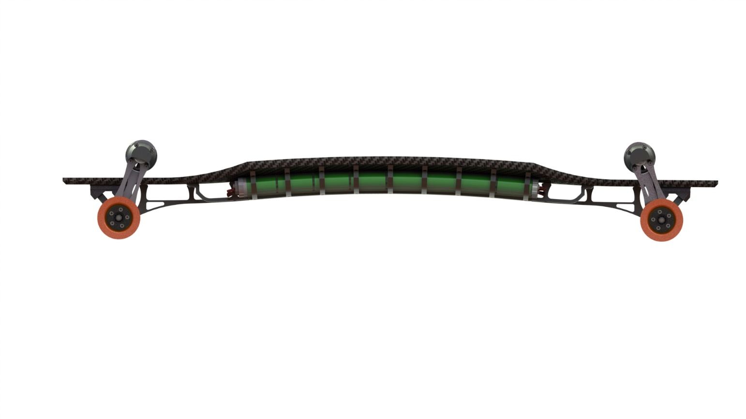

|  |
| --- |
|  |
|  |

Open-Source Project by Daniil Andreev

Oct. 16, 2017

Motivation

The reasoning behind this project it is a natural progression of my interest in longboard and previous mechanics experience, as well as making a resume that I can literally ride to an interview. However, the initiating thought was; I want build something so outrageous it exists only in a Neal Stevenson universe.

The project started during the end of my first year as an undergrad at Knox College. I had looked at the commercially available Boosted Board and figured I could make something way more powerful.

Having no training in electronics, I spent the rest of the year attempting smaller projects that would help me build the skill required to attempt an electric vehicle. 3 years later I am just starting to see the finish line.

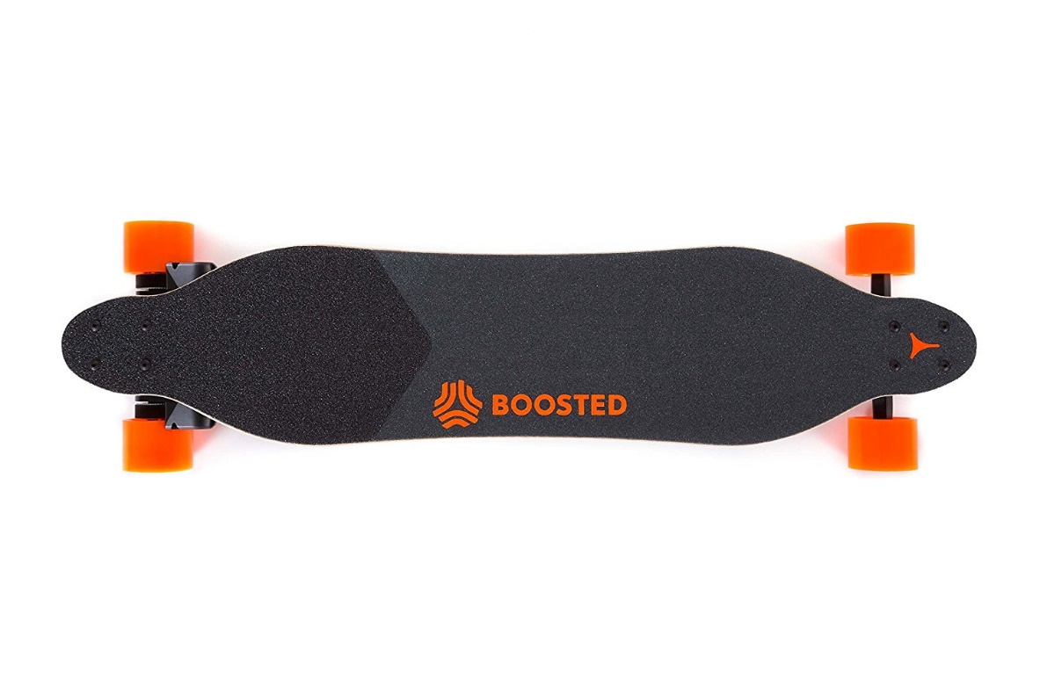

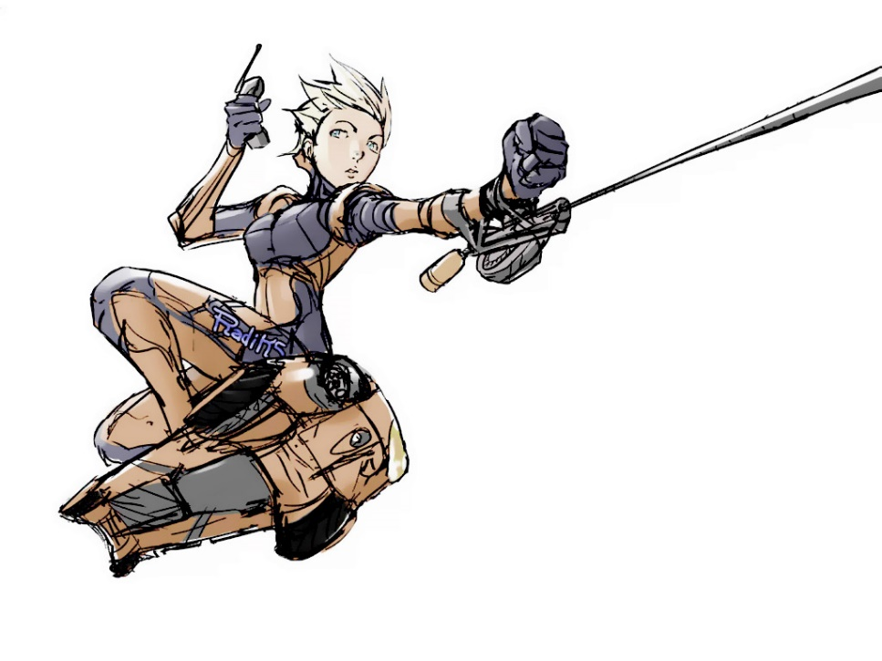

Mechanical Design and Model

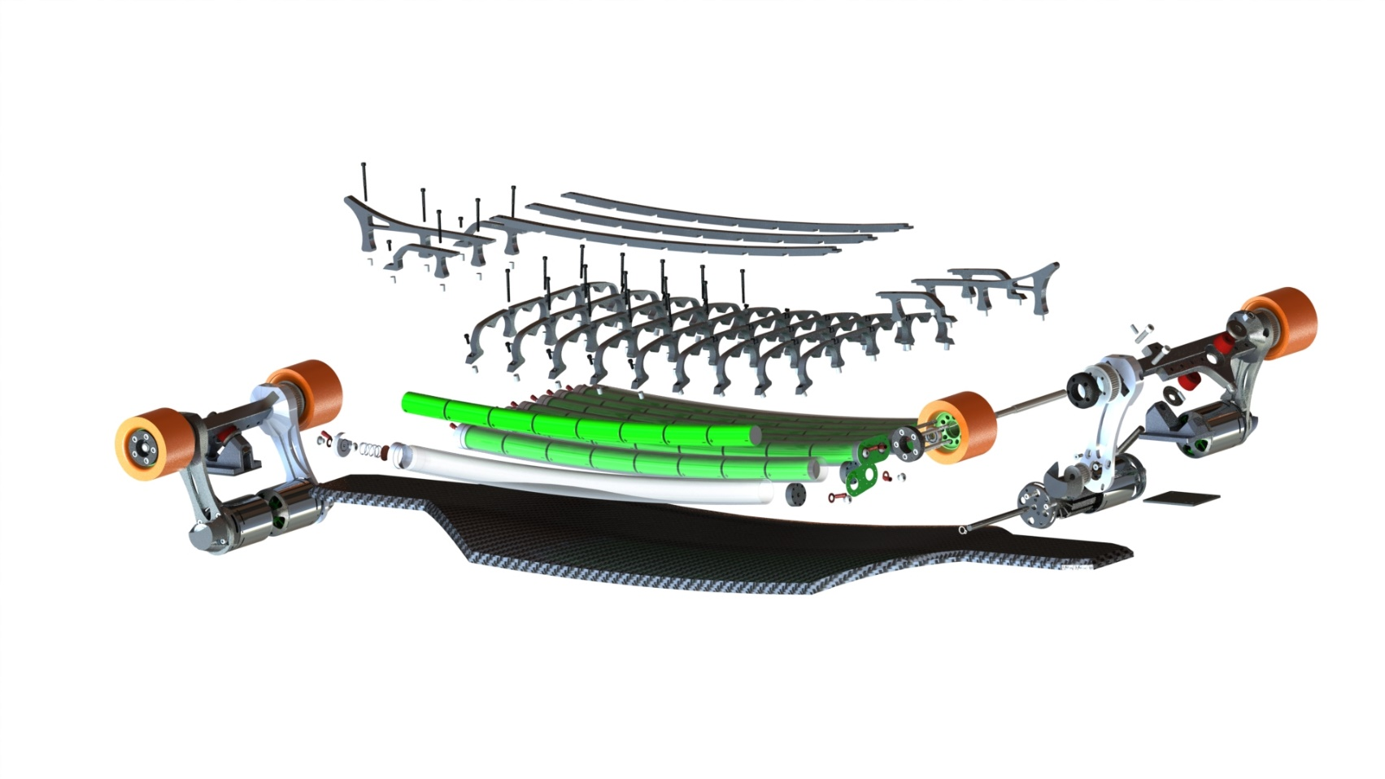A close up of a device

Description generated with very high confidenceAfter a year break in the building process I set out to reimagine the mechanical superstructure.

A close up of a device

Description generated with high confidence

Completed

2015-2016

|  |  |
| --- | --- |
| A picture containing indoor, floor, wall, table  Description generated with very high confidence A sign on the floor  Description generated with high confidence | A picture containing floor, bicycle, indoor  Description generated with very high confidence |
| V4 Carbon Fiber Deck | V2 10W RGBW Headlights, Backlights |
| 3 failed designs | 4 x ILD6150 LED Drivers  Atmel 328 Micro  12-65 operating voltage |

|  |  |
| --- | --- |
| A circuit board  Description generated with high confidence |  |
| Daisy chainable single cell BMS | V1.5 Truck and Motor Assembly |
| Attiny 85 Micro  Isolated I2C channel  Onboard boost converter | 8kW Drive train  2 x Turnigy 7464 BLDC Motors  2 x Kegel Orangatang 80mm Wheels  CNCed and turned at Redwood City Techshop. |

In the Pipeline:

2017-

|  |  |
| --- | --- |
| A picture containing indoor, wall, floor  Description generated with very high confidence |  |
| Battery Pack | Carbon fiber deck |
| 64 LiFePO4 cells to deliver 200A @ 60V continuous | CNCed Molds  Epoxy curing oven built. |
|  |  |
| A picture containing sky, electronics  Description generated with high confidence | A picture containing table, indoor  Description generated with very high confidence |
| Sensor Module | 1.5kW charger |
| Raspberry Pi central module  GPS  Altimeter  Design and development in collaboration with Sam Ragsdale | Tested at 900W without water-cooling  Compatible with 240V for 3kW+ charging  Design and development in collaboration with Anton Zaytsev |

In the Near Future

Headlight, Backlight enclosure

Integrated battery management system

Water-resistant cover

Remote-control system

2 x V2 trucks and motor mounts for the full 16kW drive train.

Learning Experience

This project helped me become a full stack developer. Having the opportunity to design and manufacture the whole project from scratch taught me to be very considerate of my design choices; making sure that the hardware is compatible with the electronics and software, striking the balance between aesthetic design and ease of manufacture. To make this board a reality I had to crawl along the entire industrial process, learning the properties of plastics, metals, composites and their respective postprocessing techniques. I learned to do the gritty work as well, to not only design and build, but talk to PCB manufacturers, spend hours on the phone with hardware suppliers, and read endless datasheets, weigh the properties of different chipsets and picking products that integrate with the full stack development process.

The top five skills that I this project taught me:

CAD – Solidworks, Eagle

Electronics – Circuit Design, PCB Design, Manufacture

C programming – Firmware development

Manufacturing – CNC, Lathe, Mill, Carbon Fiber Molding

Self-Teaching – The ability to research, learn and use any new skill or _ information that I need to push the project along

In Conclusion

Experiencing the width of the engineering process has inspired me to join a EE master program and join the hardware world to make products that have a physical impact.

Components not designed or manufacture by project team

VESC – BLDC motor speed controller

Turnigy 6374 BLDC motors

Nyko Wii nunchuck – repurposed for the control of the ESCs

Kegel Orangatang 80mm Wheels

More Info

[Hackaday Project Page](https://hackaday.io/project/26899-electric-longboard-markii)

[Github](https://github.com/lolomolo/LongboardMarkII)